**Steps to clean up workspace using freestyle job-**

There is a “Workspace Cleanup Plugin” installed in Jkci which (when used) deletes the workspace before the build or when a build is finished and artifacts saved.  
Option for deleting workspace **before** build is in **Build Environment** section: “Delete workspace before build starts”.

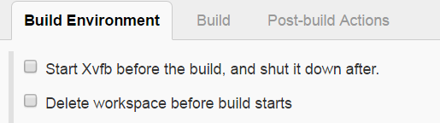

Option for deleting workspace **after** is in **Post-build Actions** section:

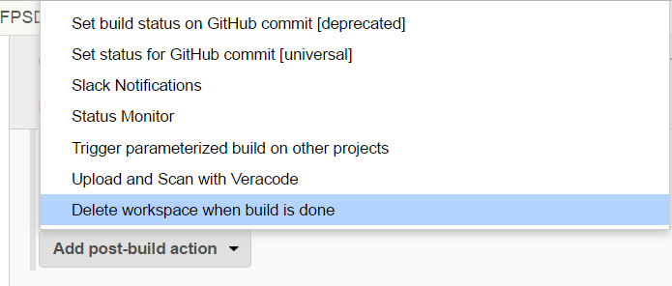

By default, the entire workspace will be deleted. You can make it more selective by specifying here some file patterns to select only a subset of the workspace.

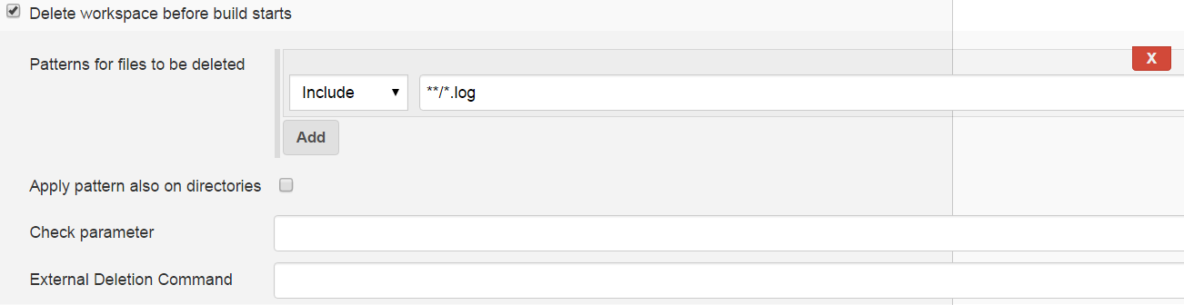

Pattern is typed into the field. In select box we need to choose if the pattern is include pattern (if the file matches this pattern, file will be removed) or exclude pattern (if file matches this pattern, file won't be removed).

Patterns are applied only on files. If you want to apply them also on directories, check checkbox “**Apply pattern also on directories**”. Please note that directory is deleted with all content, so if the directory matches include pattern, everything in this dir will be deleted no matter if some files in this dir matches exclude pattern.

Example of the patterns:-

**/*.class

matches all .class files/dirs in a directory tree.

test/a??.java

matches all files/dirs which start with an 'a', then two more characters and then ".java", in a directory called test.

**

matches everything in a directory tree.

**/test/**/XYZ*

matches all files/dirs which start with "XYZ" and where there is a parent directory called test (e.g. "abc/test/def/ghi/XYZ123").

**Check parameter** - Set this field to a boolean environment variable, which will be checked if the workspace will be actually cleaned up or not. If the variables value is set to true then the workspace will be cleaned up and else not. (Specify only the variable name like "VARIABLE").

**External Deletion Command** - If set, an external deletion program will be run against files and directories.

Syntax: program_name [program options] %s

Where program_name is the program to use, path, or environment variable. program options are any switches to send to the program. %s will be replaced with the path to be deleted dynamically.

**Steps to clean up workspace using jenkinsfile (pipeline job)-**

We need to use [deleteDir()](https://jenkins.io/doc/pipeline/steps/workflow-basic-steps/#deletedir-recursively-delete-the-current-directory-from-the-workspace) as the last step of the pipeline Jenkinsfile.

The deleteDir function recursively deletes the current directory and its contents.

To delete a specific directory of a workspace wrap the deleteDir step in a dir step within the pipeline script -

dir('directoryToDelete') {

deleteDir()

}